# AIO438 I2S manual

By default the AIO438 receives I2S from the Bluetooth module, which sends either the wireless stream or the analog input. This document describes how to use the I2S header as input or output.

## Header

|  |  |
| --- | --- |
|  | From left to right:  DAT: Data, also known as SDIN/SDOUT  CLK: Clock, also known as SCLK/BCLK  WS: Word-select, also known as LRCLK/FS |

The partnumber of the header is B3B-PH-K-S(LF)

## I2S specifications

Voltage: 3.3V

Sample rate: 44.1/48K

Bit depth: 16/24/32bit accepted as input. Output is 16 bits.

## As output

The header can be used as output to another I2S-compatible amplifier.

## As input

The header can be used as input for an external source. To prevent the Bluetooth module from powering on and generating I2S, send “BT disable” to the amplifier using the configtool while the amplifier is enabled. It should respond with a confirmation. The external source can now be connected to the header.

Start your I2S source and enable your amplifier to check if music plays.

## Troubleshooting

- Keep wires as short as possible

- Verify I2S signals with an oscilloscope

- Use the configuration tool (zoudio.com/configtool) to connect to your amplifier. It will be disabled by default, when you send something it will turn on. Now you can request the amplifier status by sending “STATUS”. Both amplifiers should be in PLAY state. It is normal that the PLL is not locked. If there are any errors detected, they will be listed.

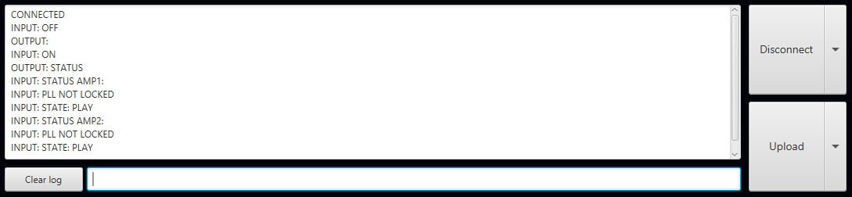

- Any remaining questions can be sent to info@zoudio.com